Jenkins pipeline exercise

1. **Open up Jenkins**

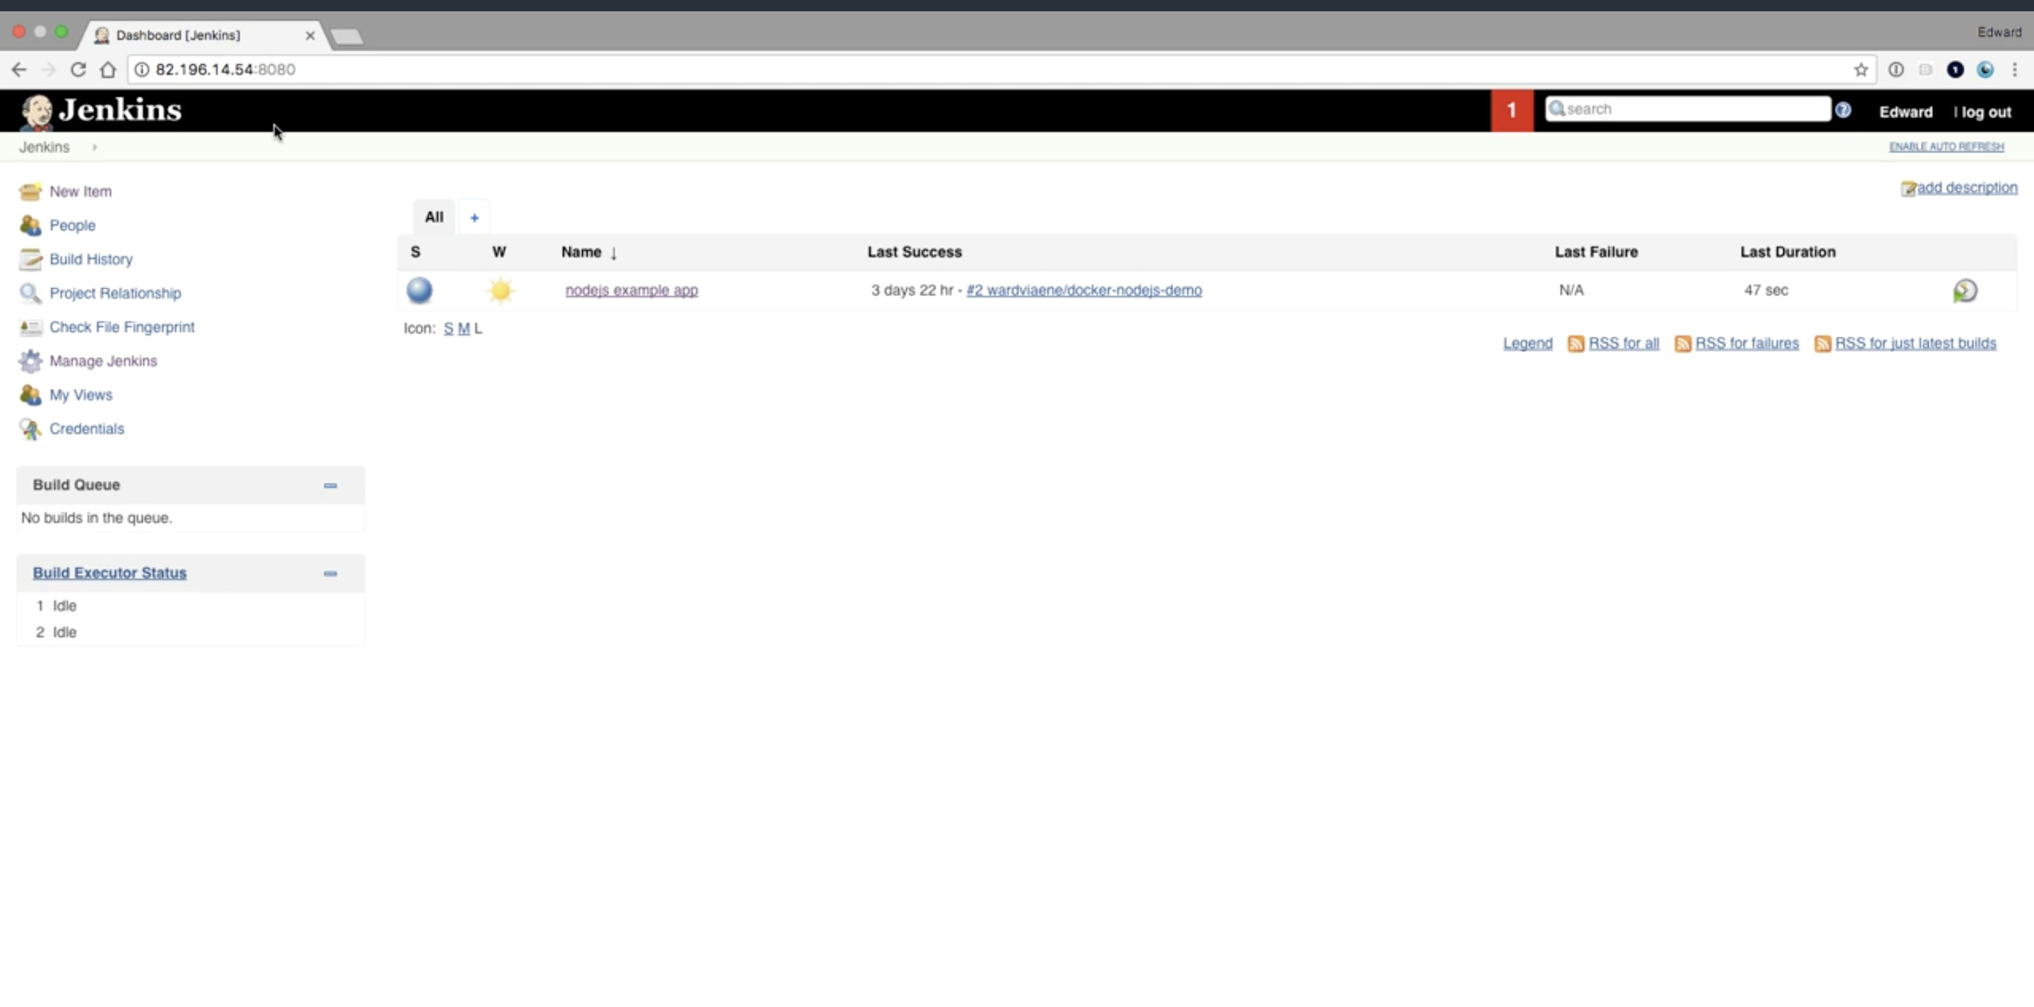

**Make sure you have job dsl plugin installed**

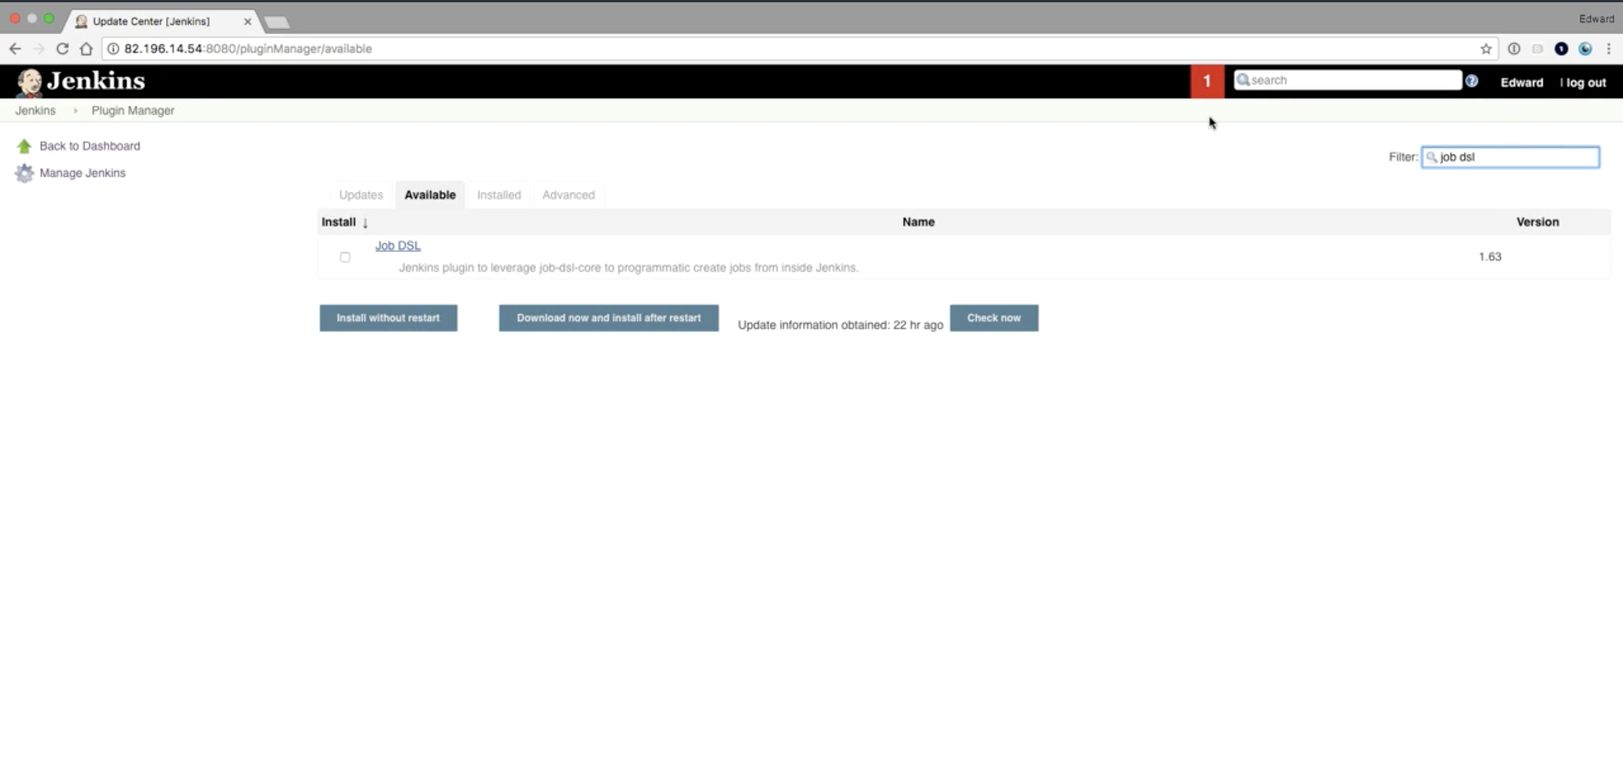

**Go to create a new item**

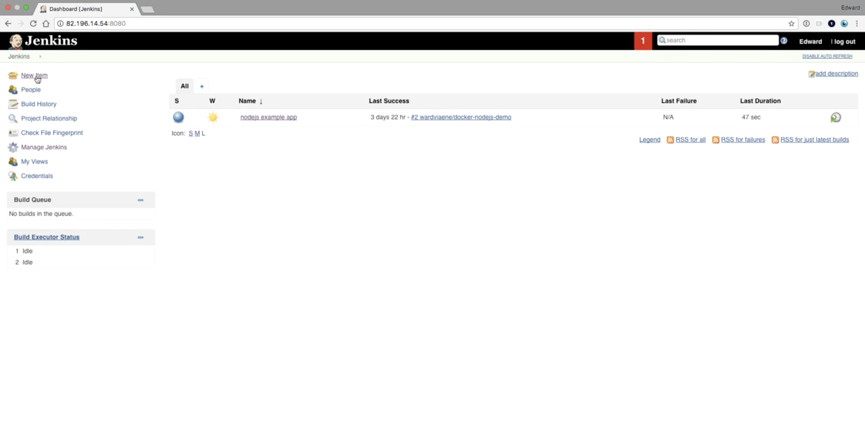

**Create a freestyle project**

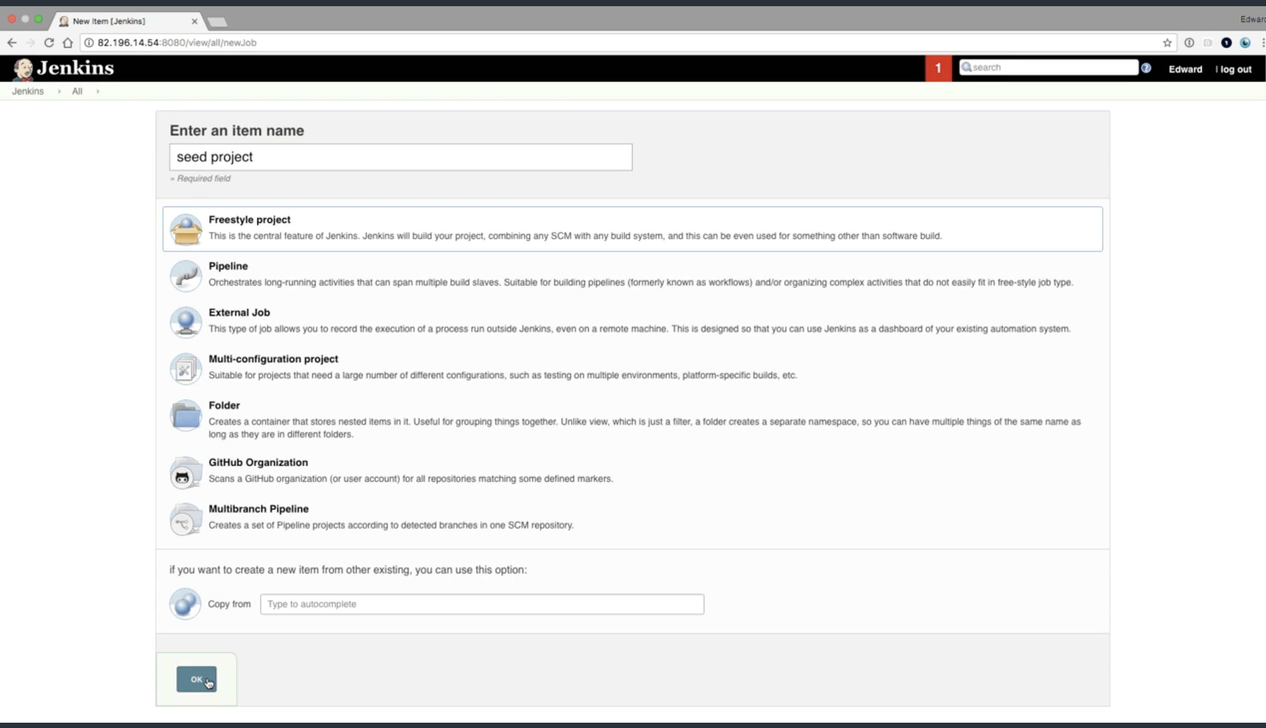

**This the source code for this project**

[**https://github.com/Lidorlg/jenkins-course/blob/master/job-dsl/nodejs.groovy**](https://github.com/Lidorlg/jenkins-course/blob/master/job-dsl/nodejs.groovy)

**so fork the code**

**and put it in git setup inside the job**

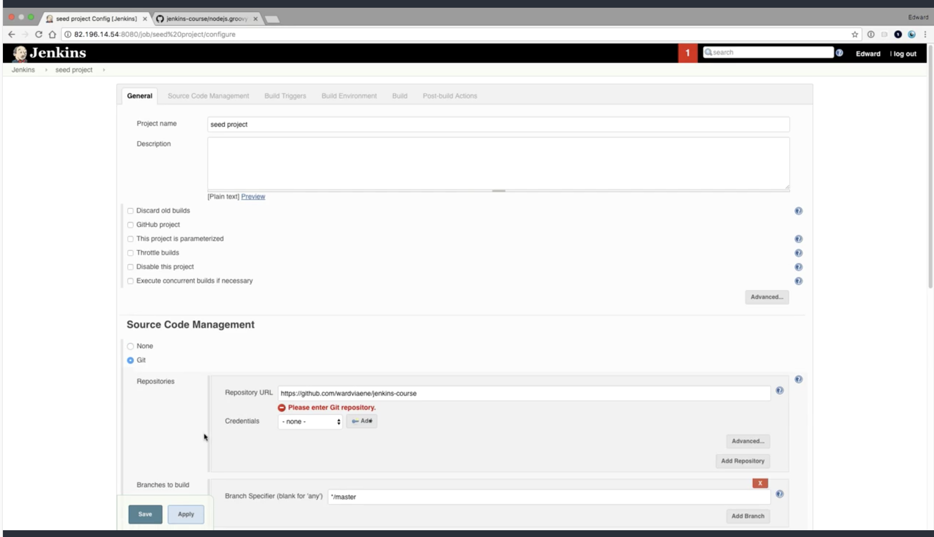

**Now add a build step :**

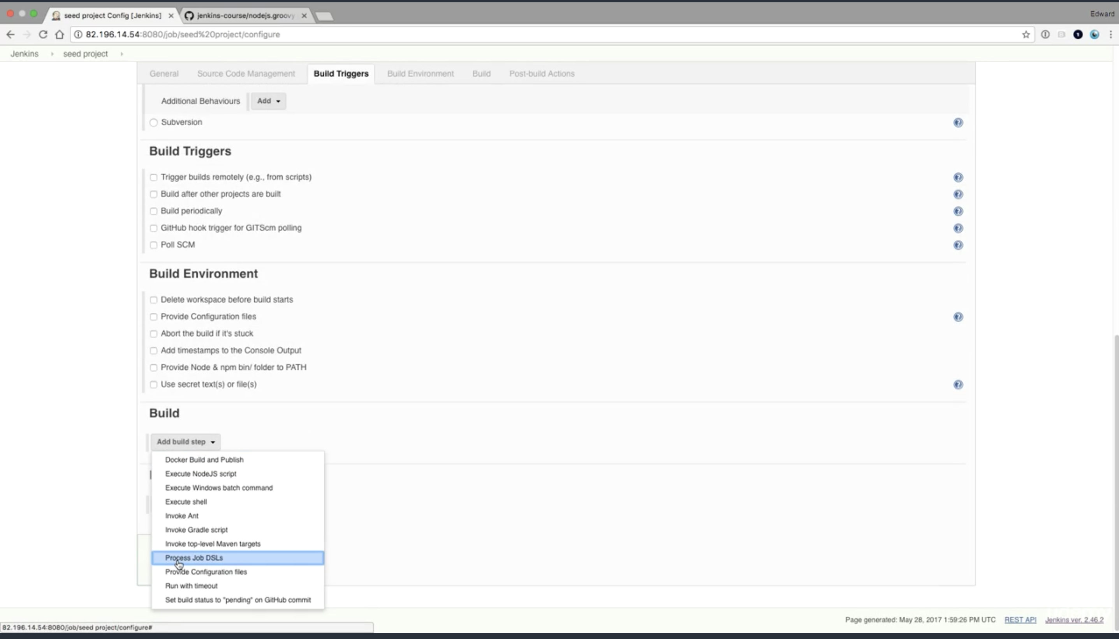

**This will be the dsl it will process**

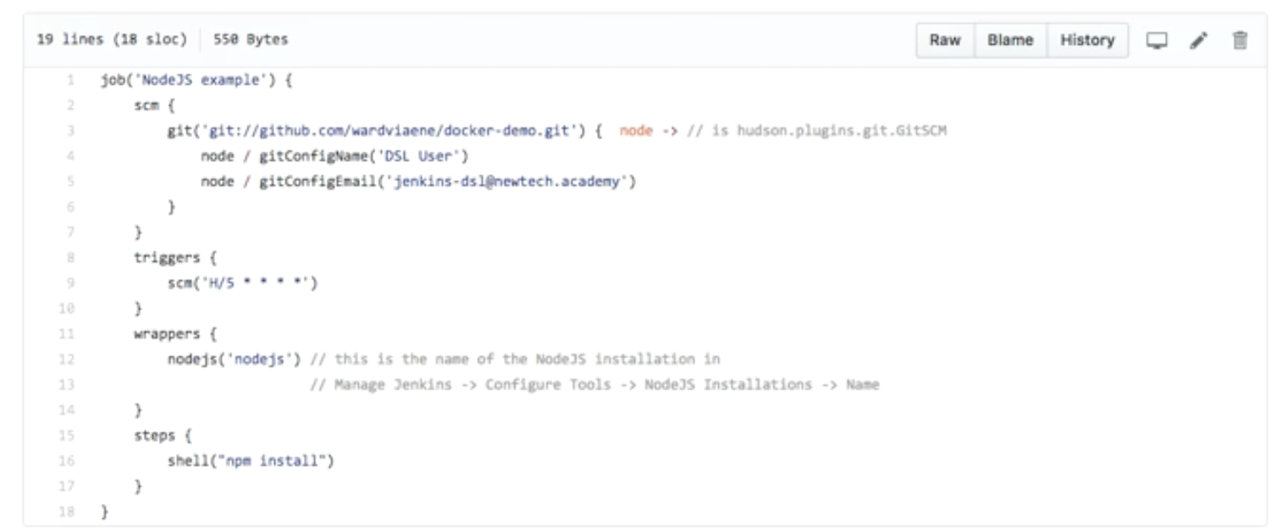

**Point it in the dsl scripts**

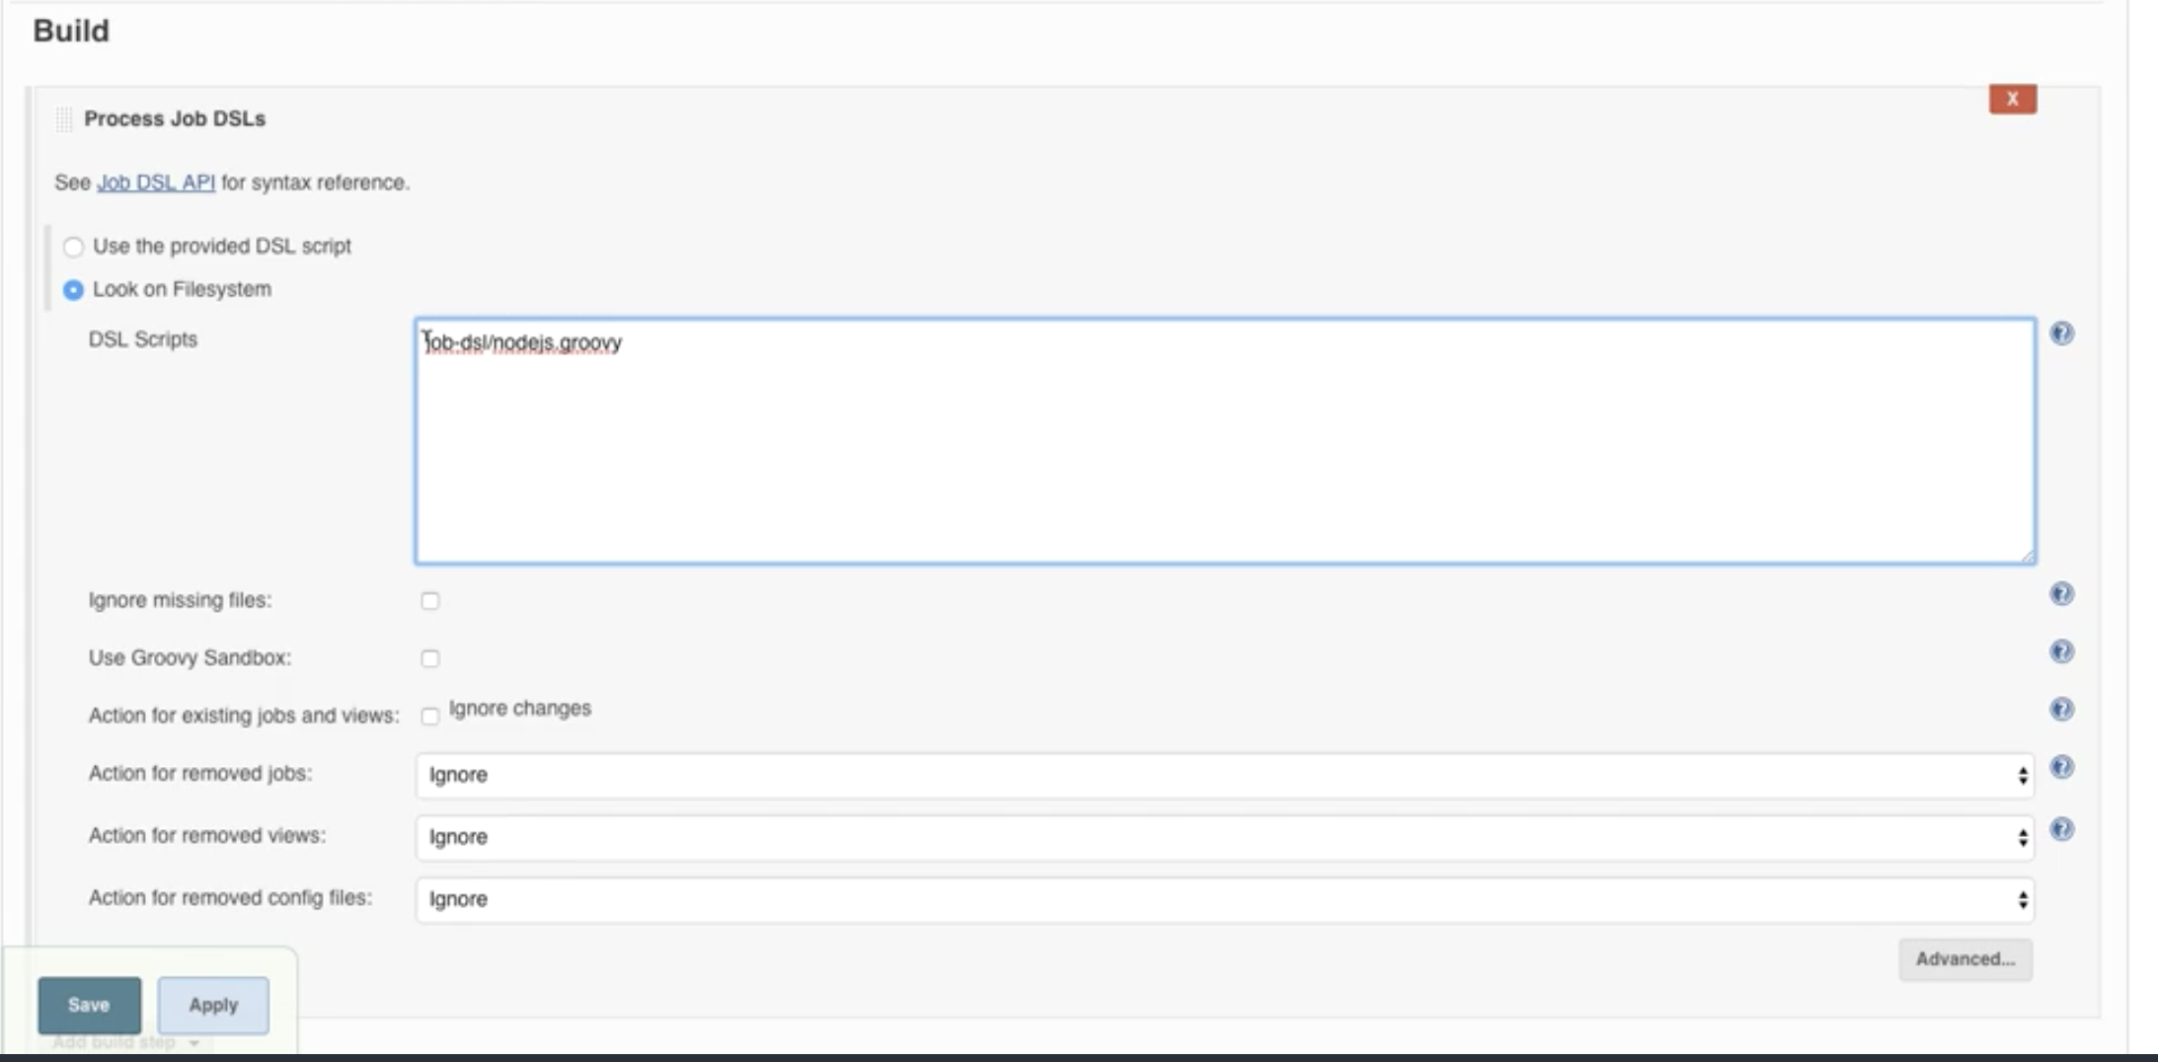

**Now run the job**

**It will fail and that is ok**

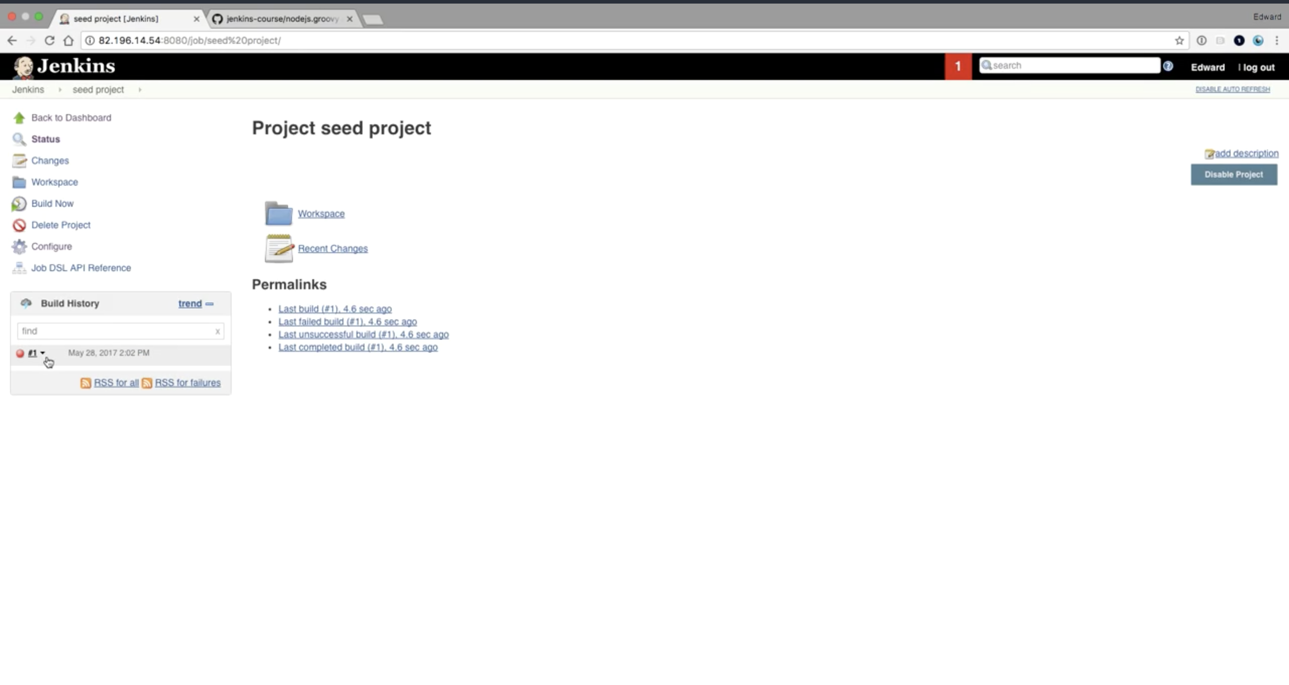

**Go to the console output**

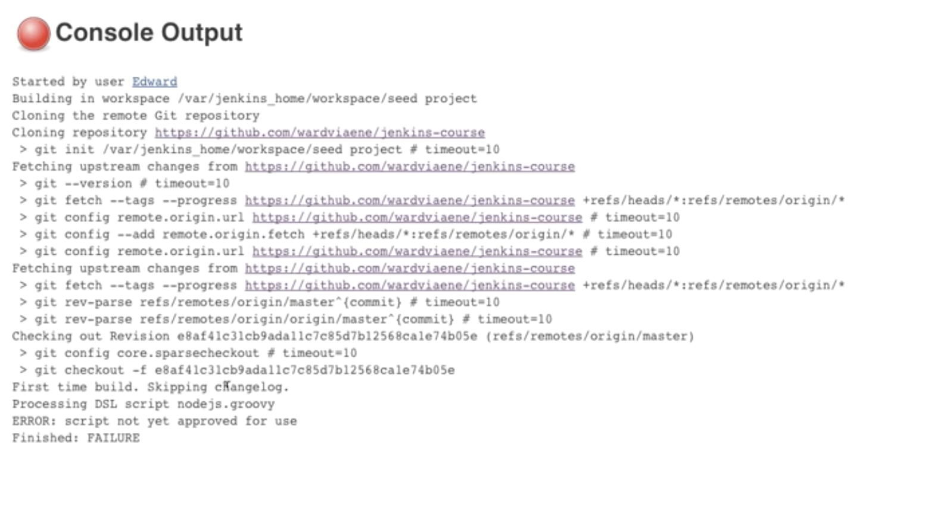

**You have to approve the script first in Jenkins**

**Go to manage Jenkins**

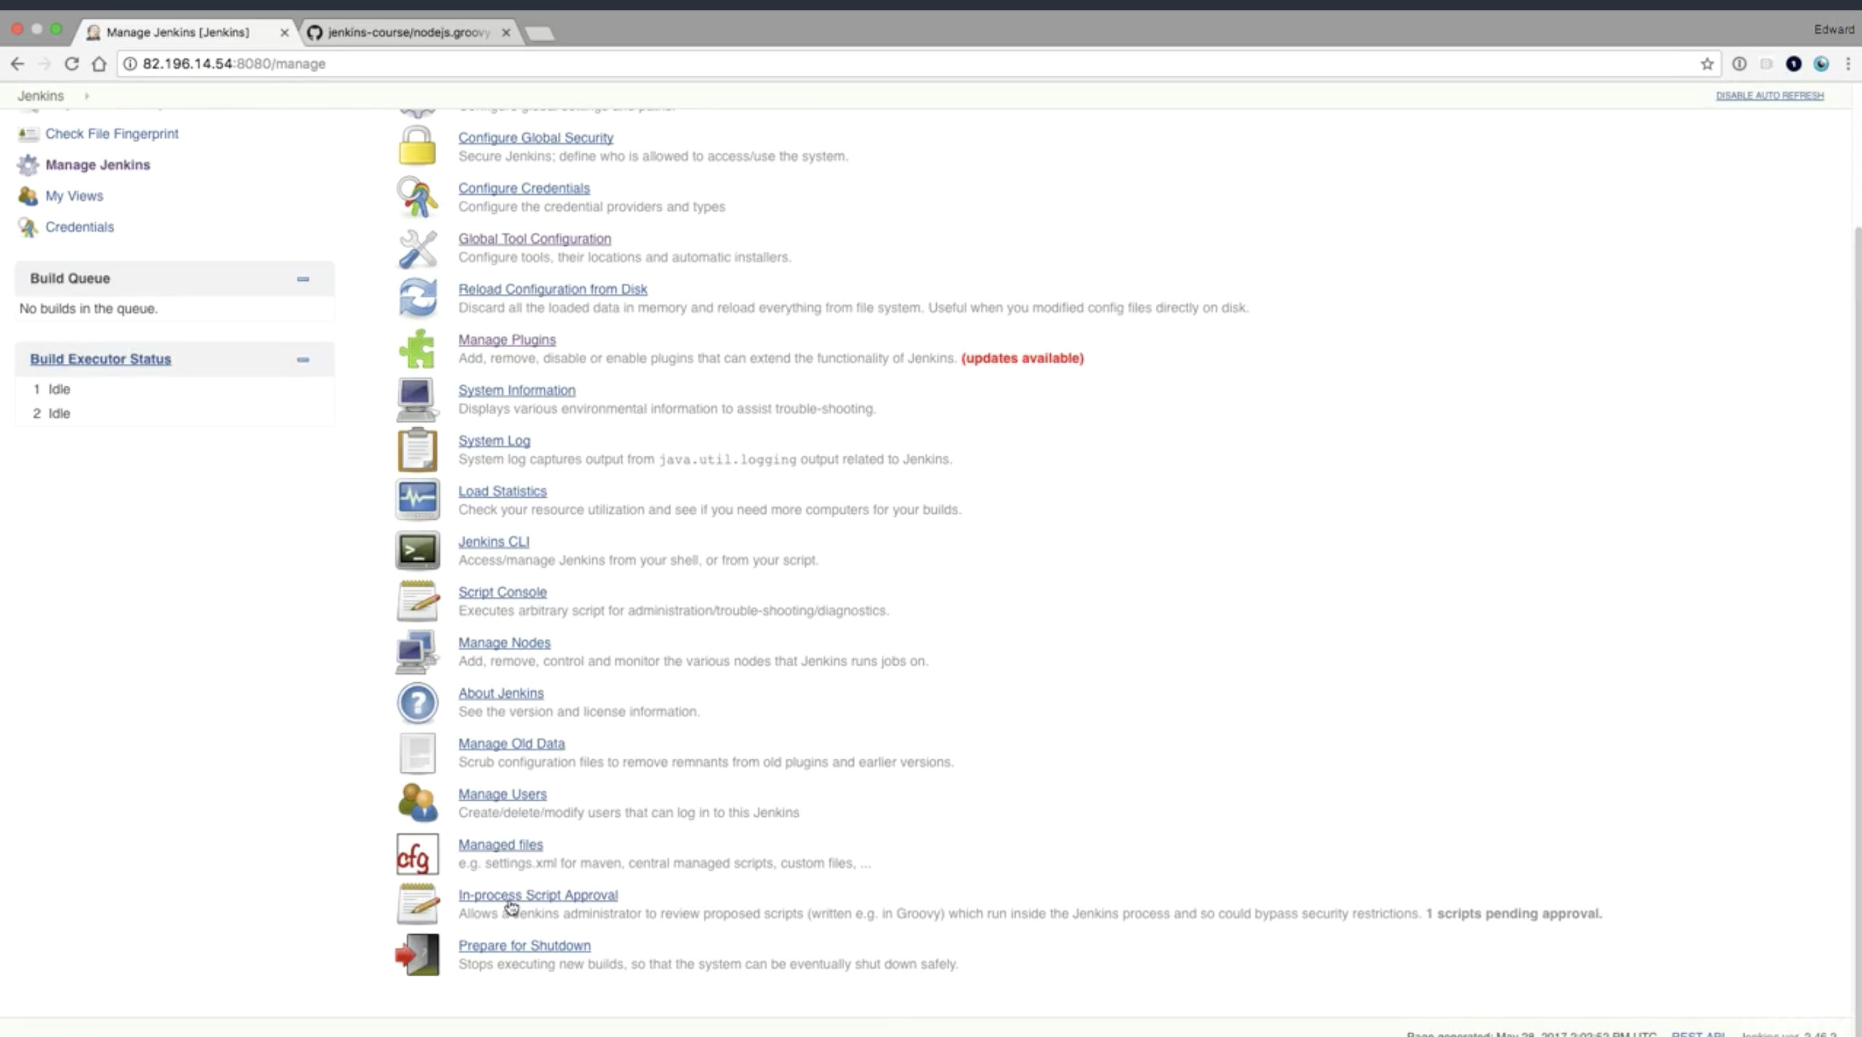

**In process script approval**

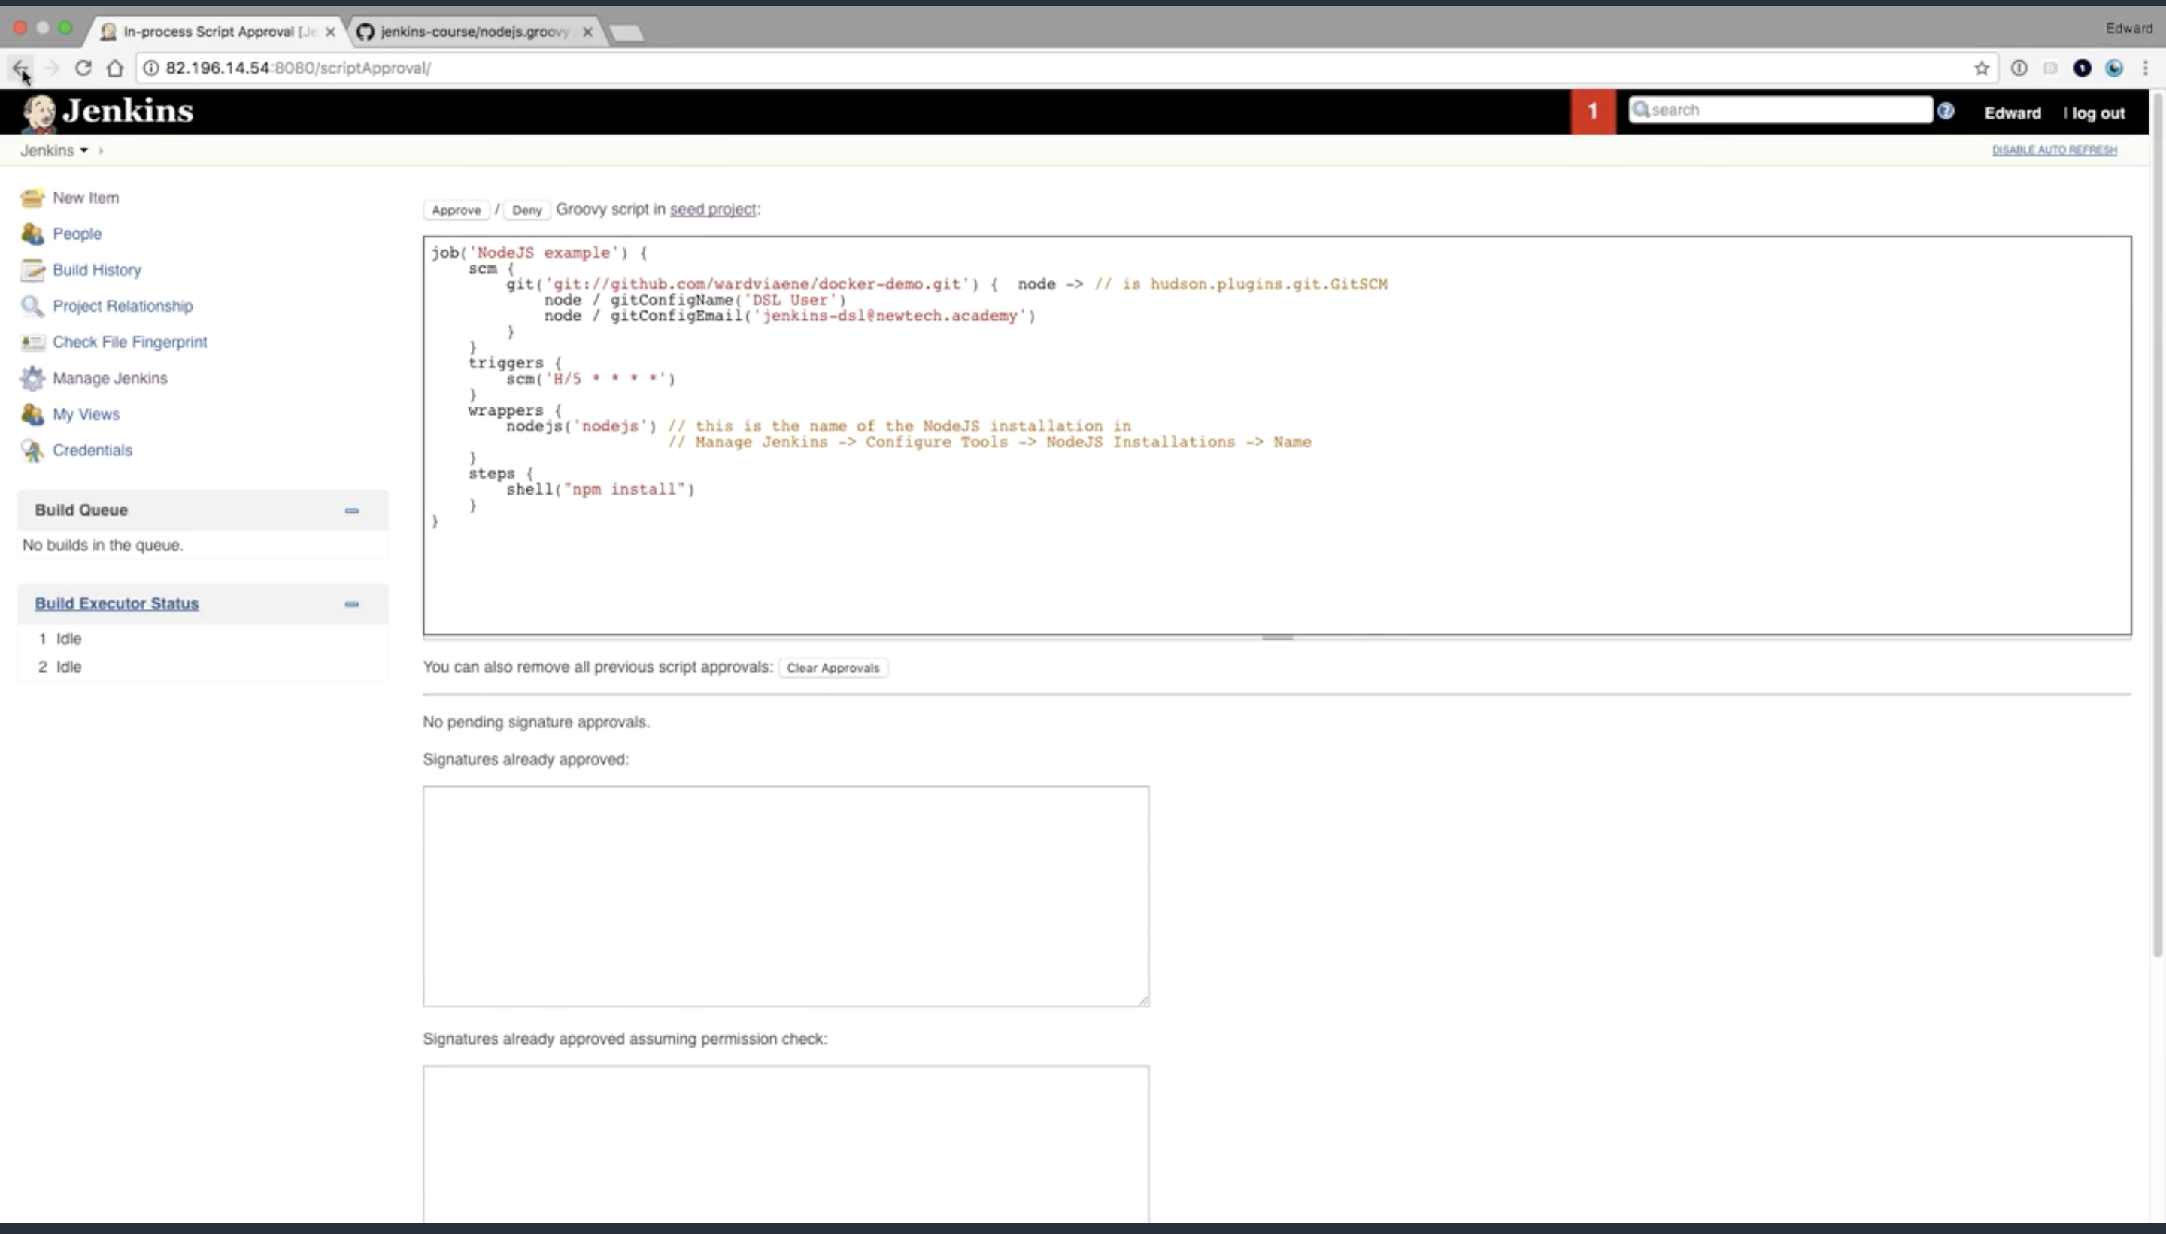

**Clicl approve**

**Run the job again**

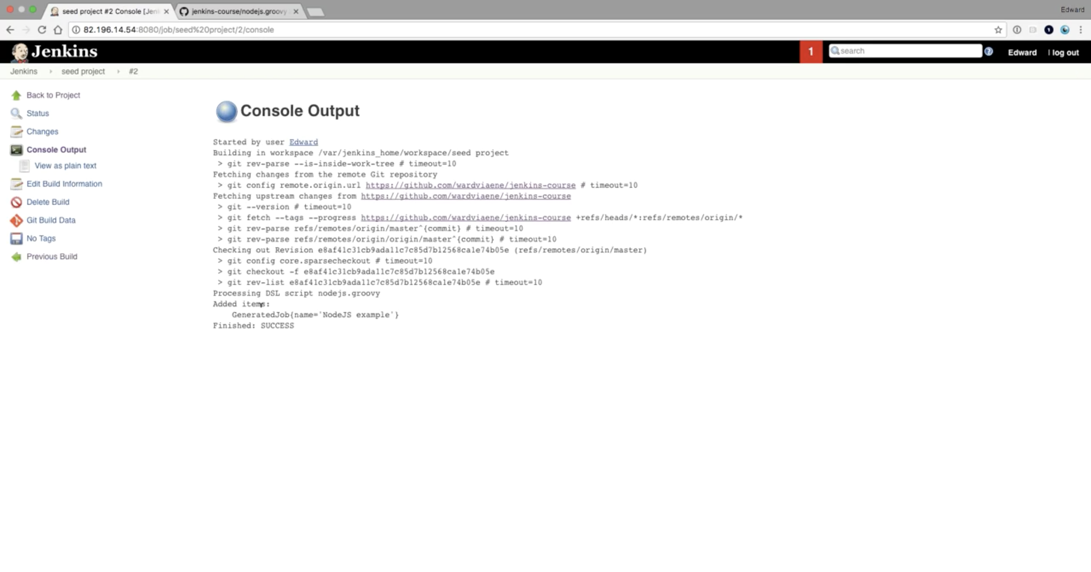

**You will see a new job Nodejs Example**

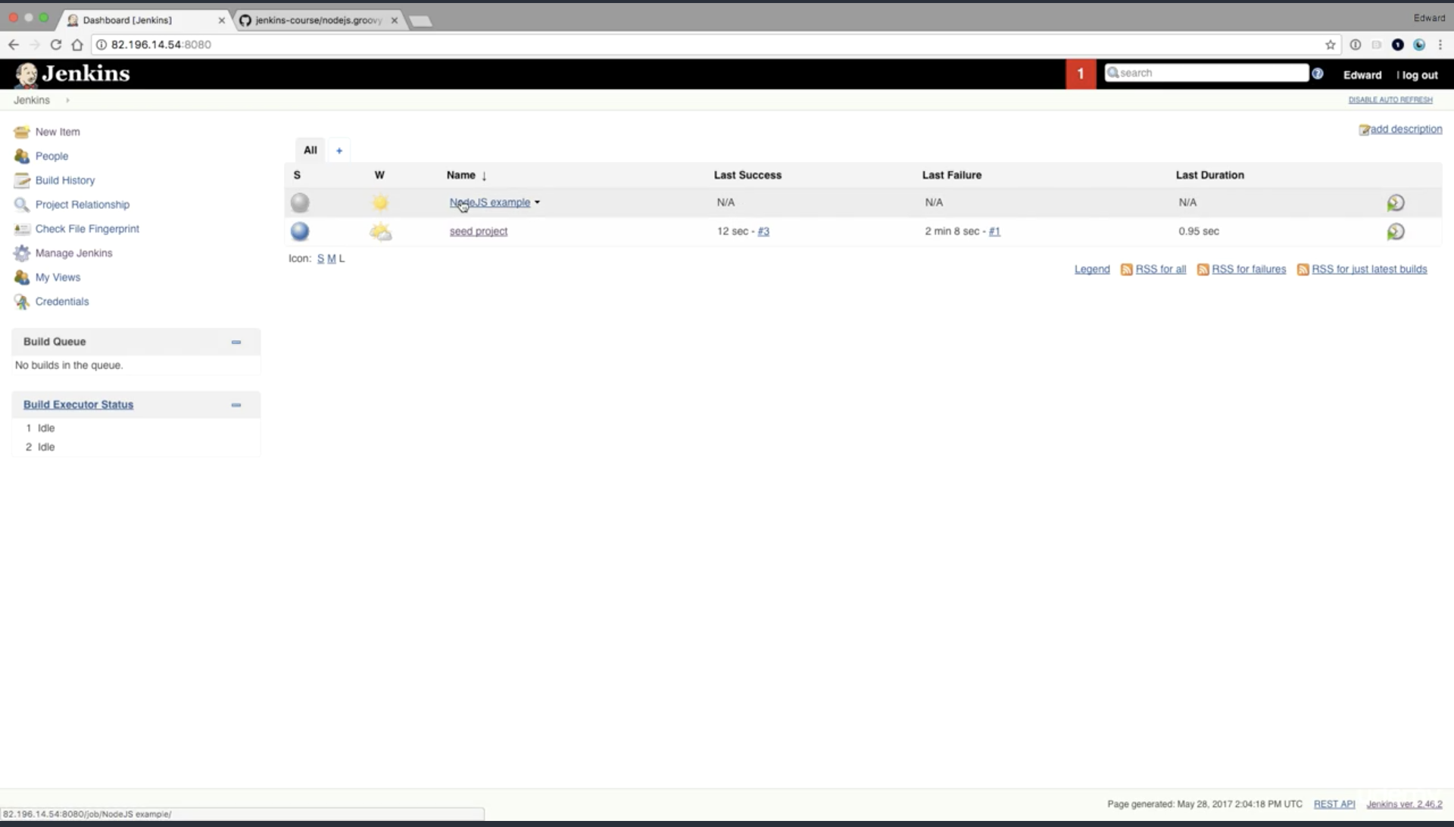

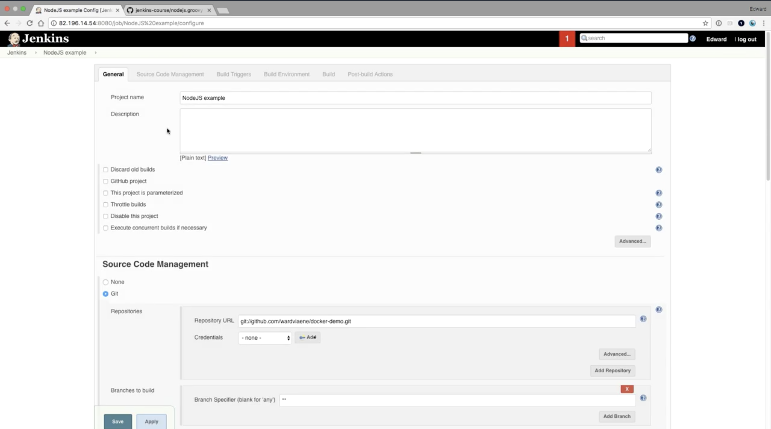

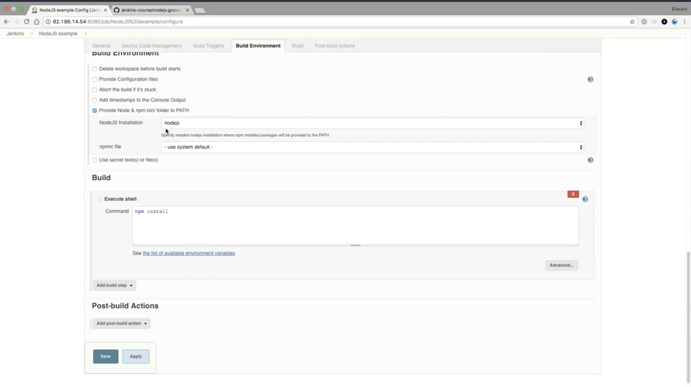

**Make sure oyu have nodejs tools install first (npm)**

**Run the NodeJs example build**

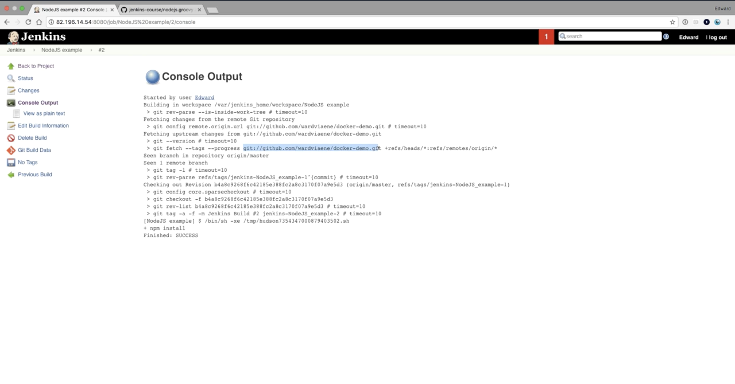

**Now this part of exercise is finished**

**Learn pipelines first then proceed**

**Pipeline Execise:**

**Make sure you have pipeline plugin installed in Jenkins**

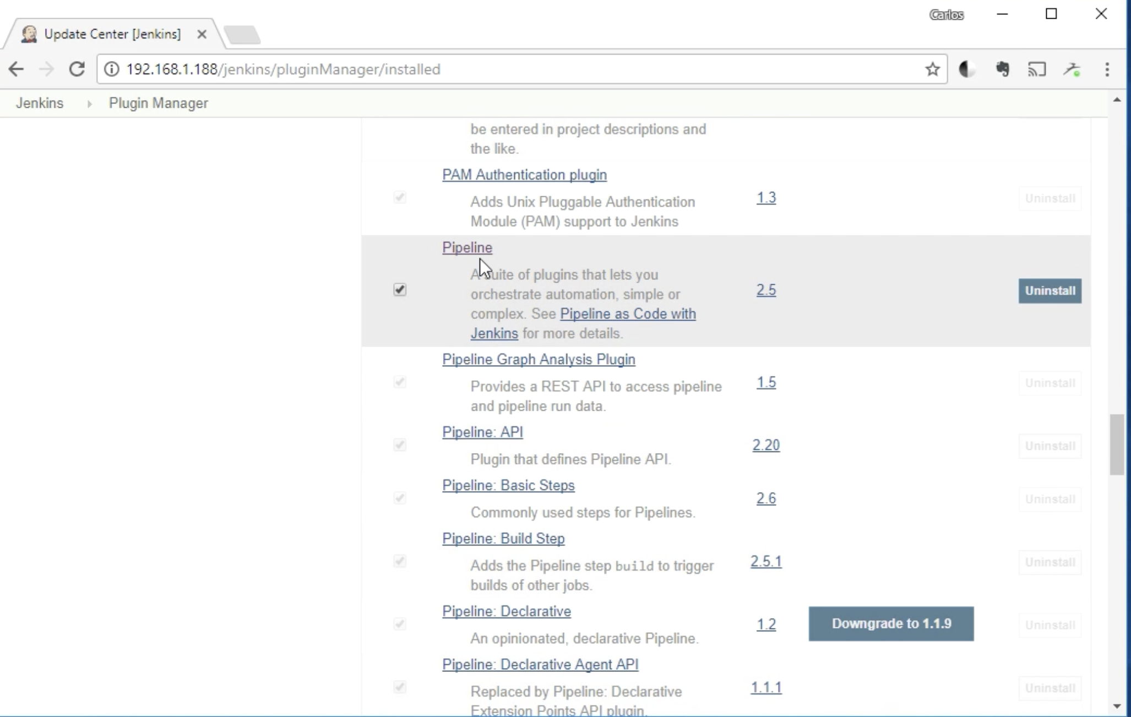

Create a new item in Jenkins

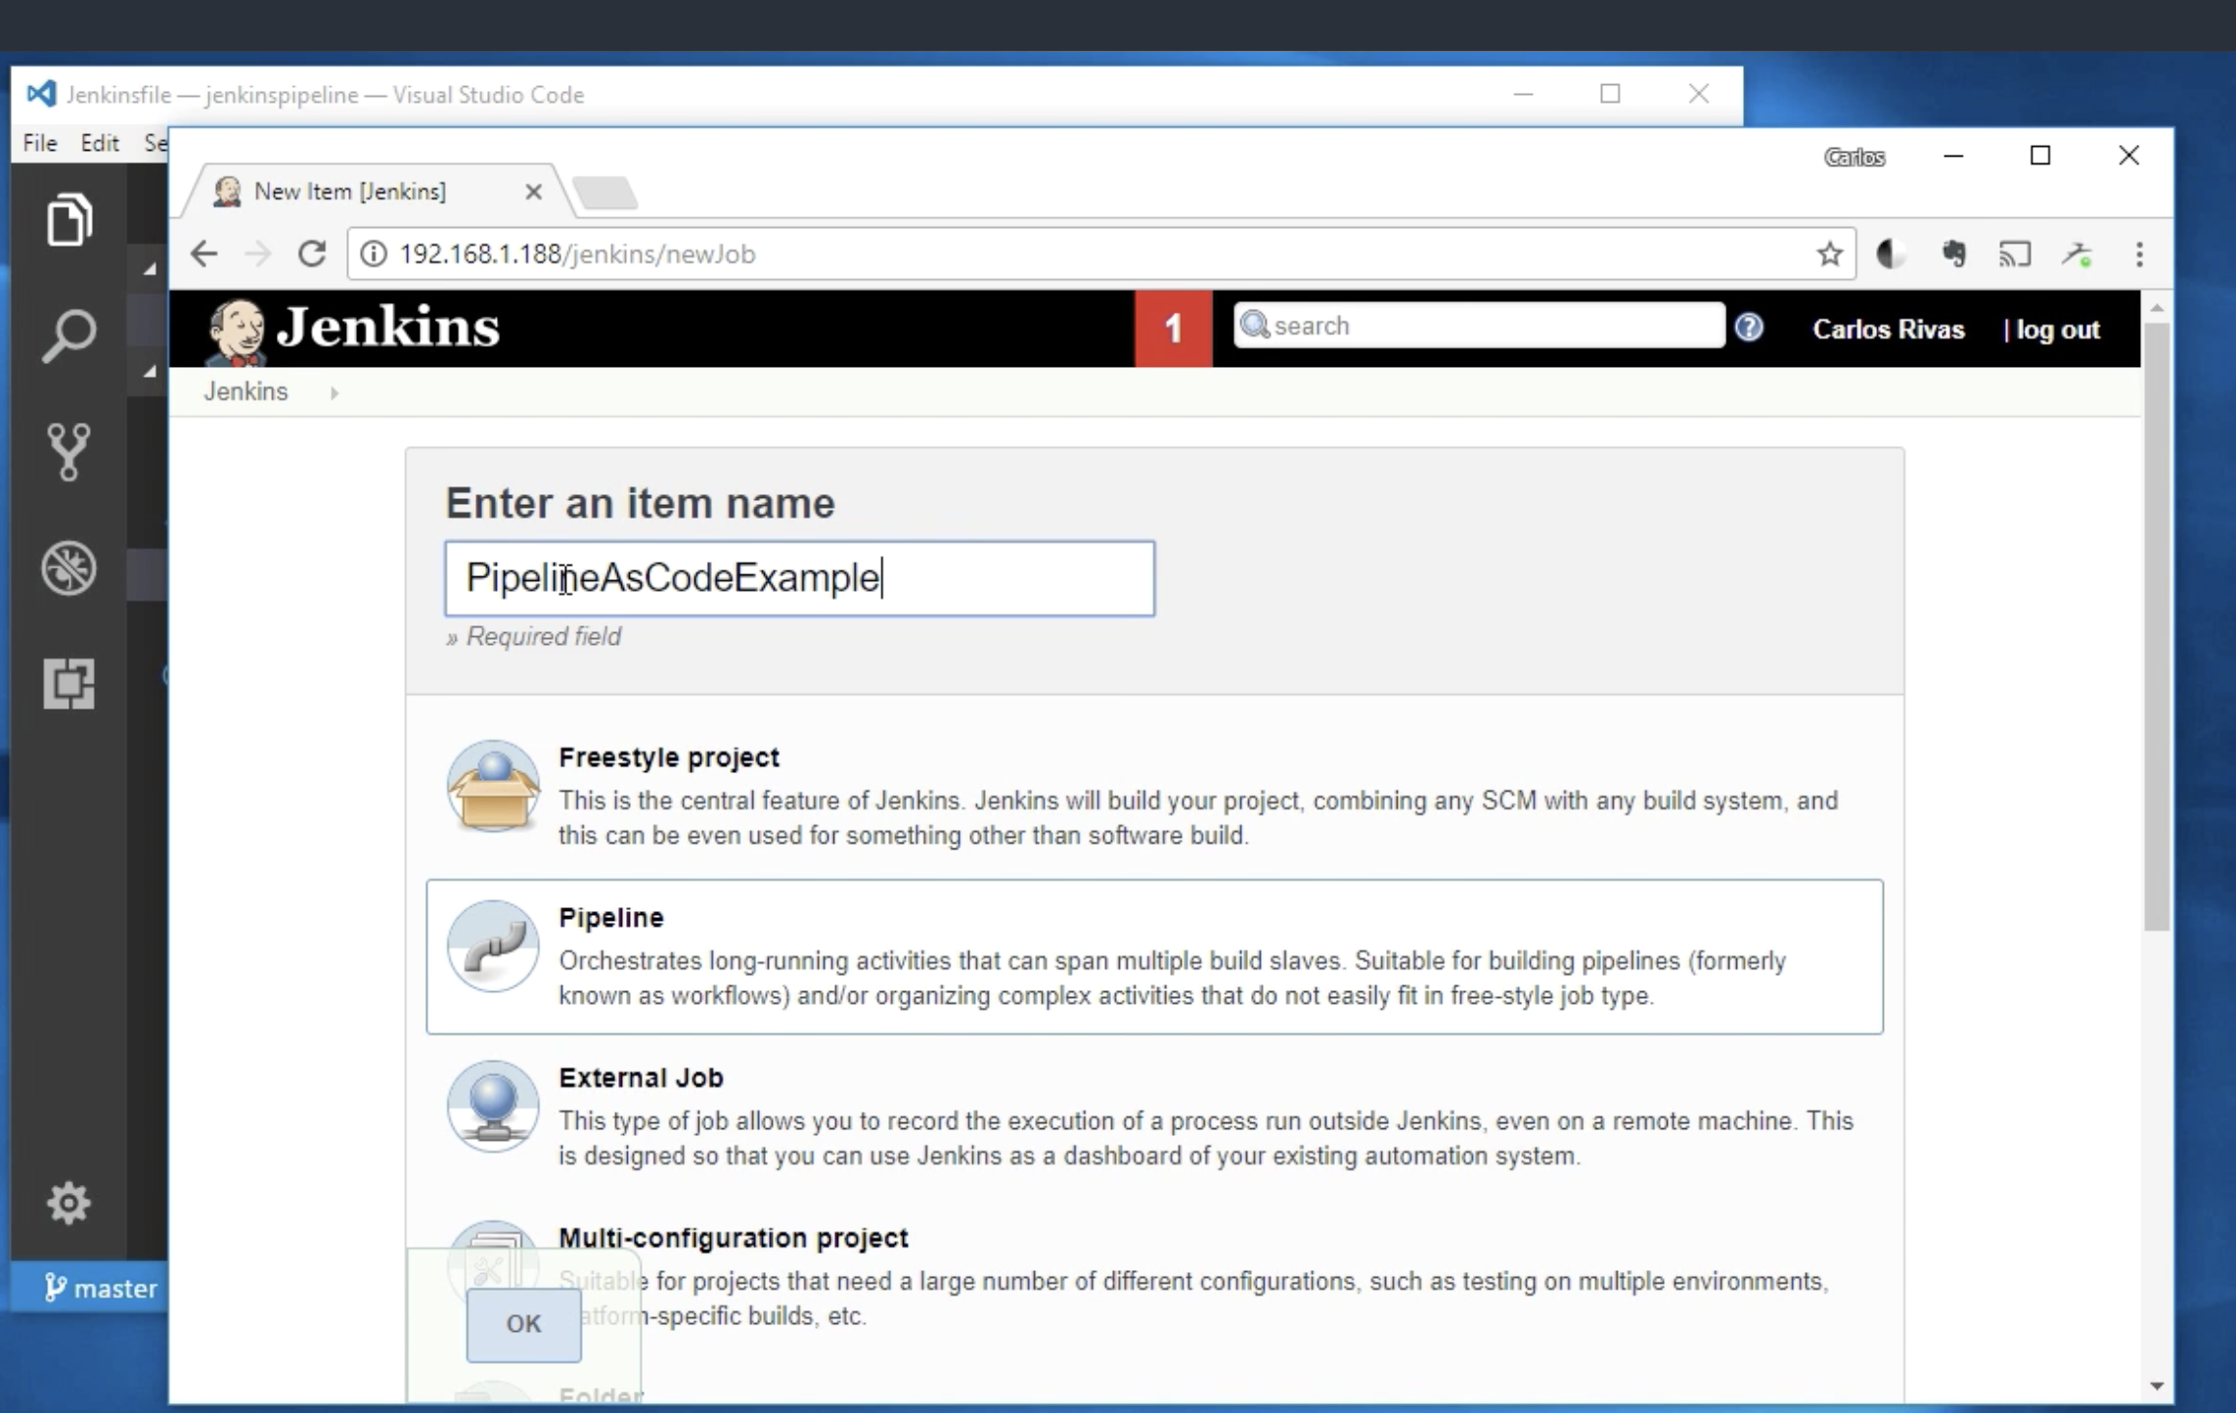

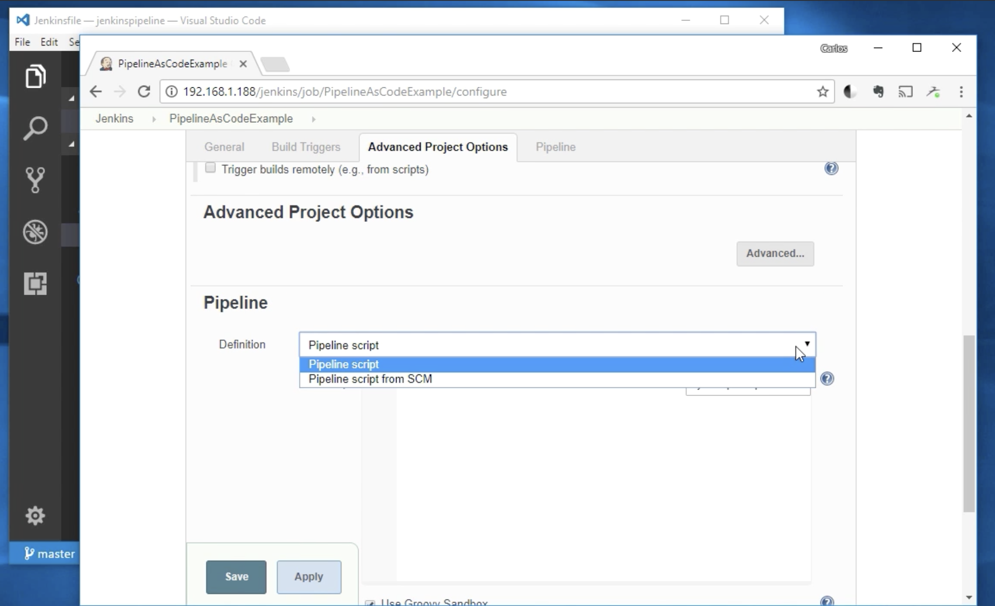

Now choose pipeline from SCM

And SCM should be Git

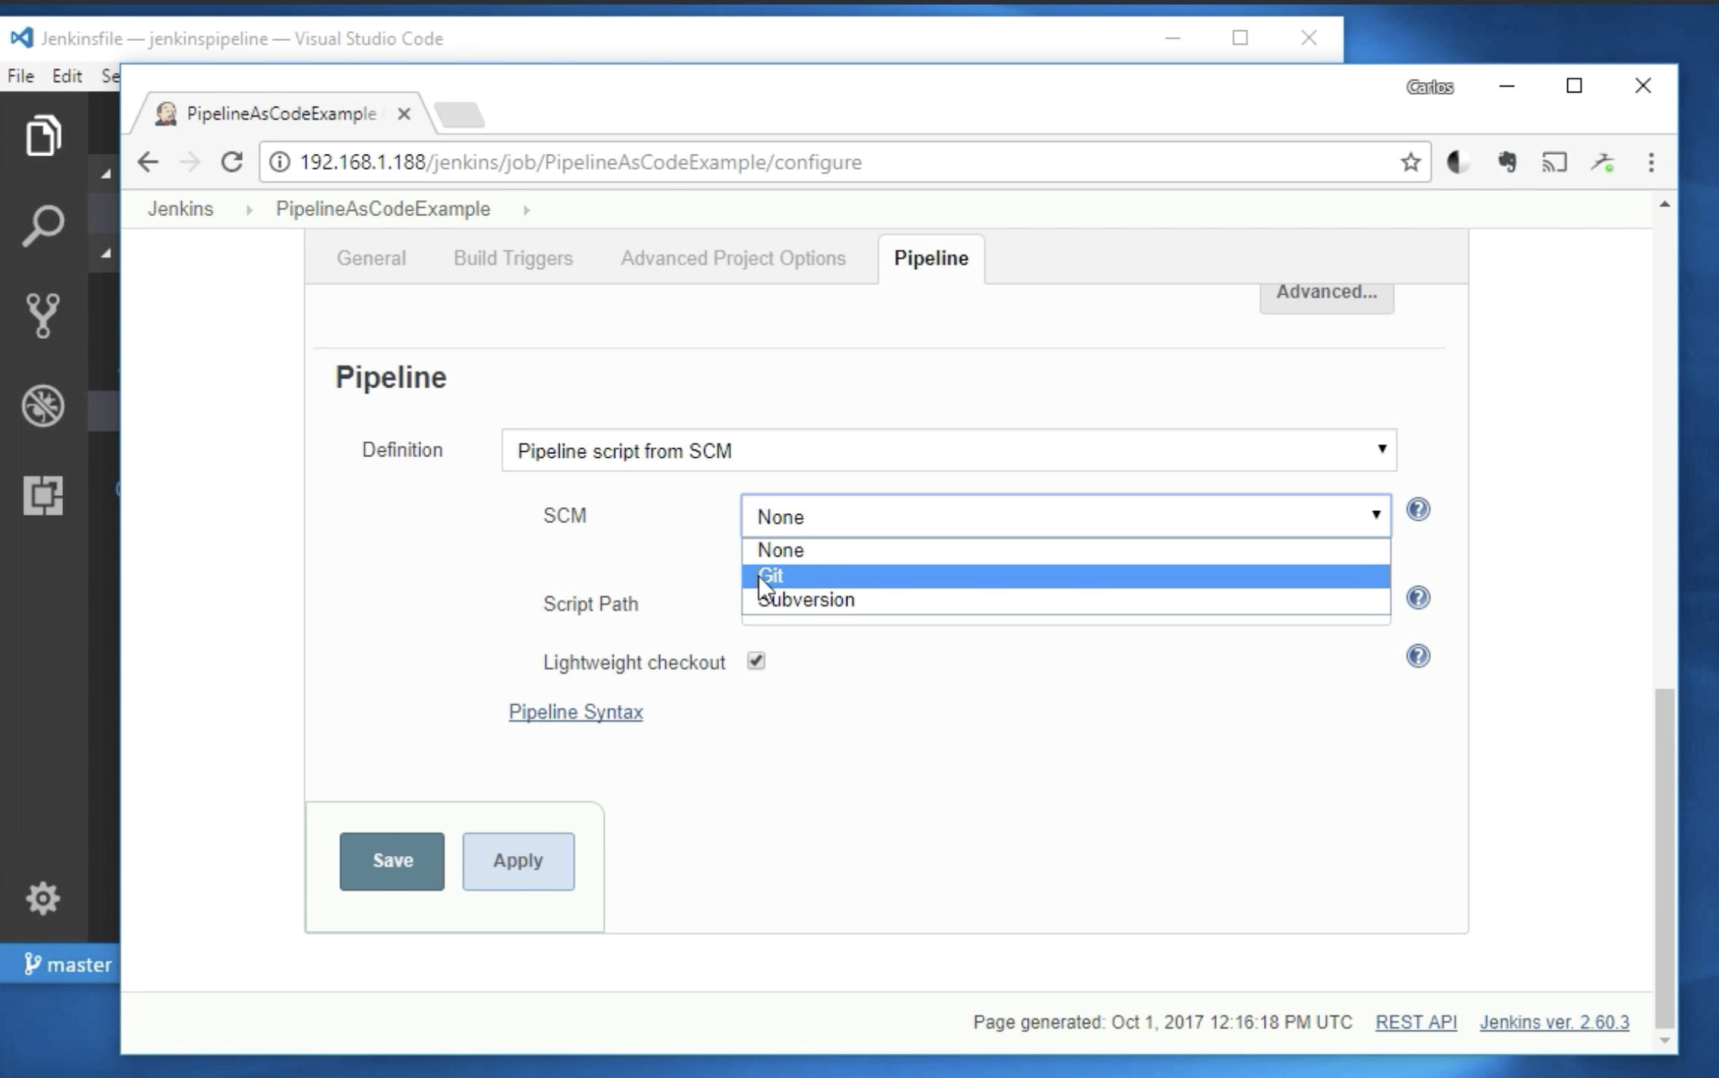

Now fork this project first from Github :

<https://github.com/Lidorlg/jenkinspipeline>

and insert your as git url

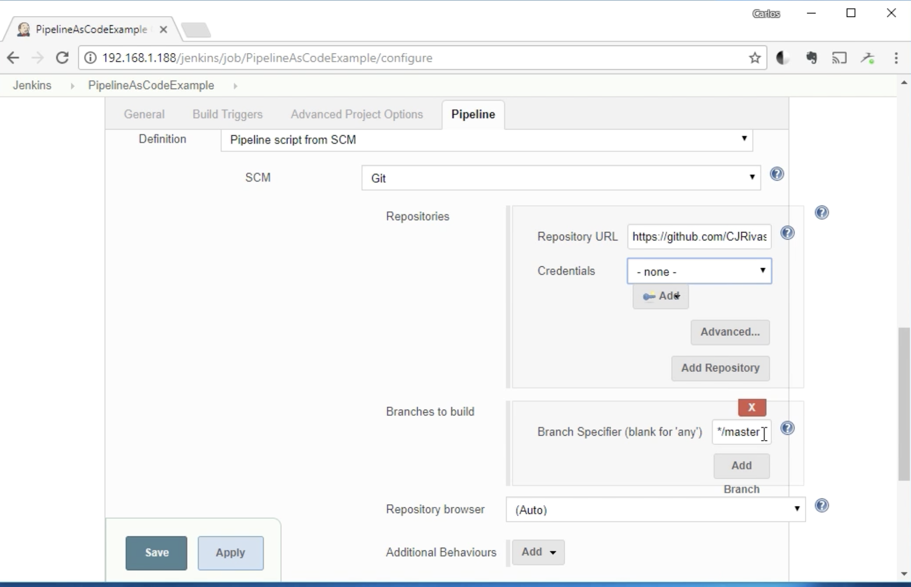

Now hit save

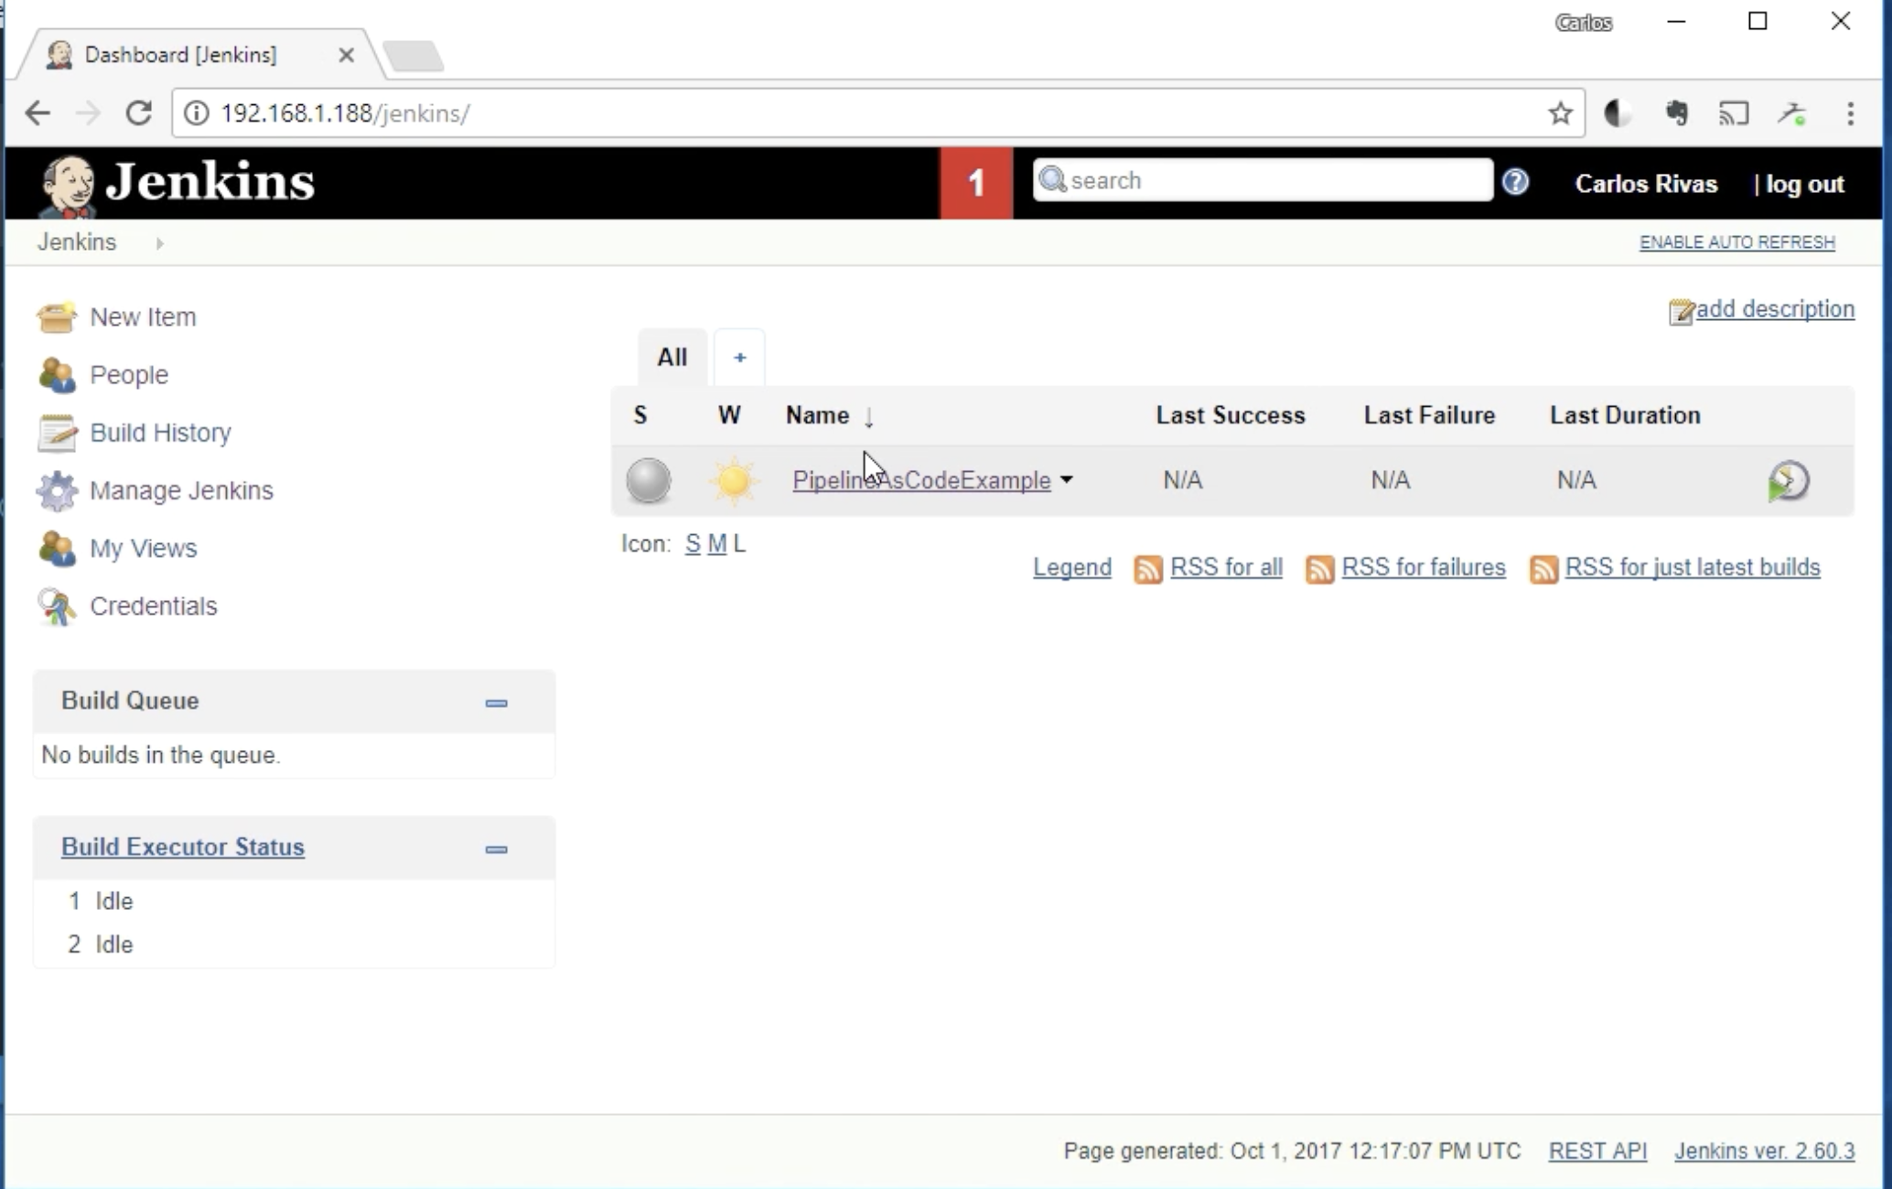

This is a dummy jenkinsfile

Now you can run the pipeline as see what runs:

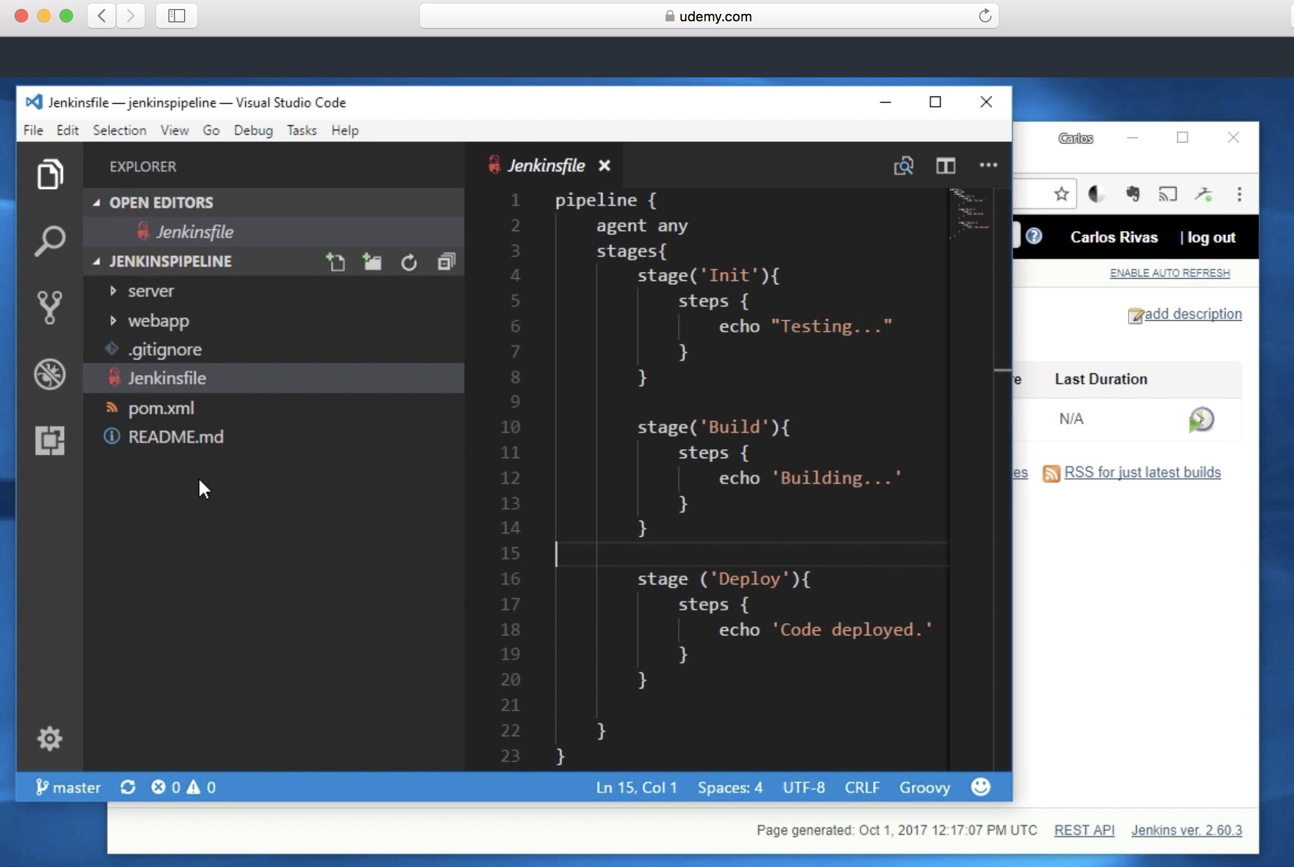

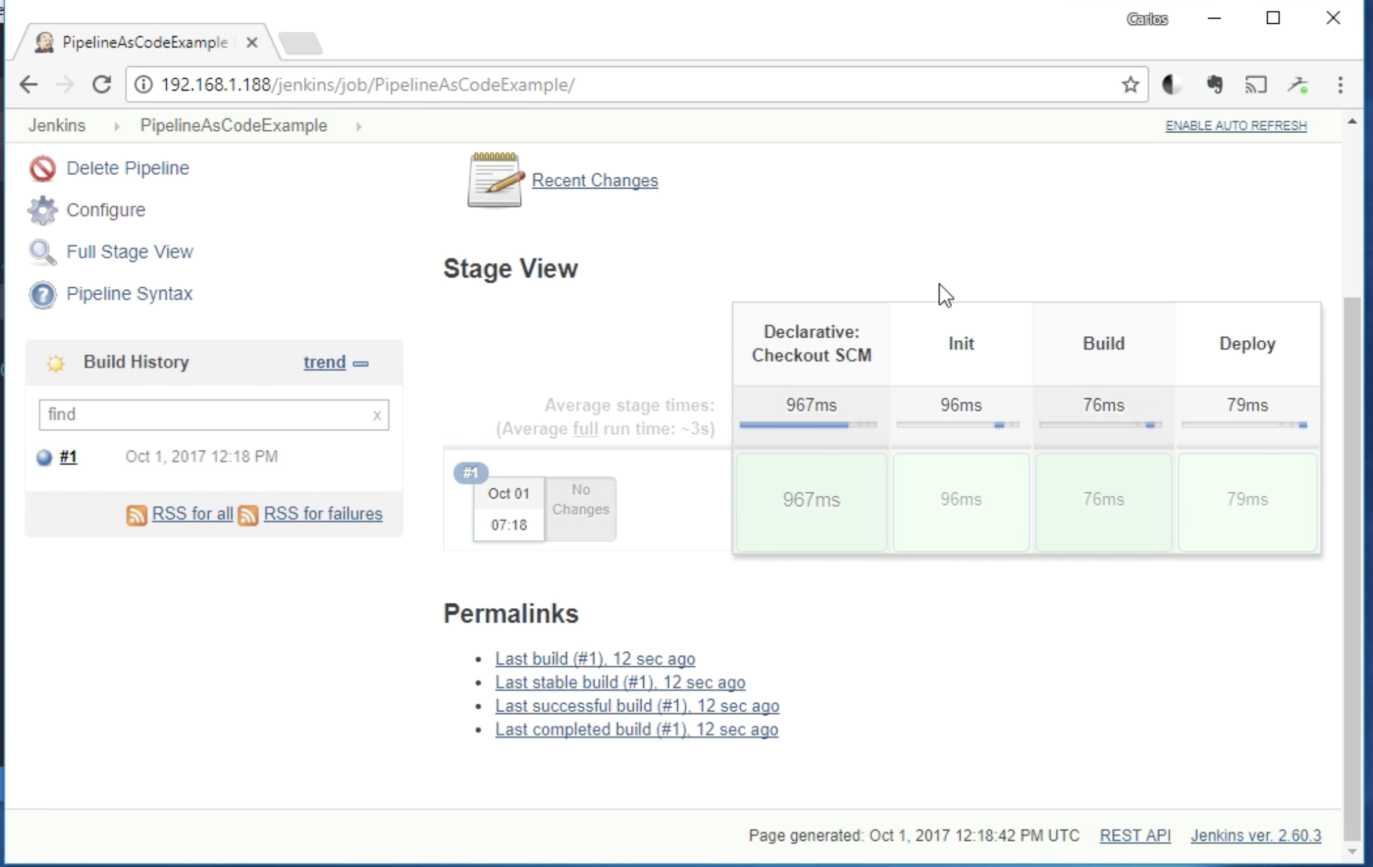

Go to console output and see what is inside

Now let’s actually build step with maven

So prepare your jenkisfile :

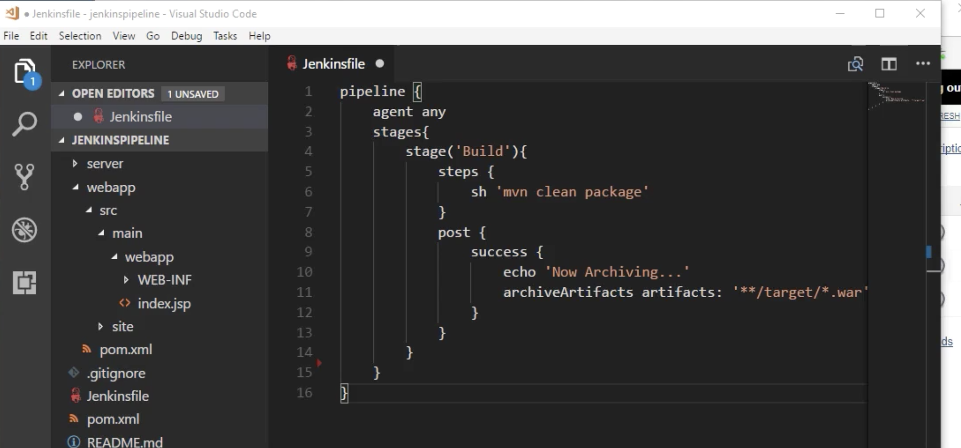

Git commit it to your repo and push it to github

Now run the pipeline

Go to console log in Jenkins pipeline

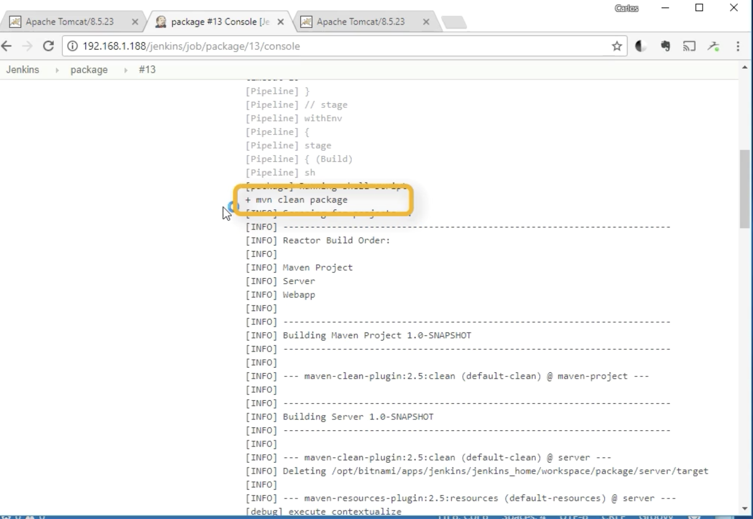

Now lets do a deploy

Prepare tomcat on linux

And run this with your parameters

Change the command instead of bat to run on linux

And use scp and not winscp command to copy the files

